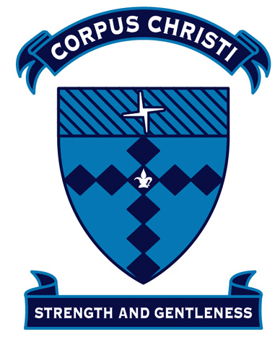 | Curriculum Note  Year 3 and 4 - Stage 2  Term 3 – 2019

Religious Education
Our Catholic faith is the basis of all interactions and classroom practices. We aim to create classroom environments based on peace, justice, respect and tolerance.
The modules we will be studying this term are:

The Story of My Parish
In the first two weeks of term we will study The Story of My Parish. This module expands students’ knowledge of the life of the local parish community. Students will be encouraged to grow in appreciation of people who assume leadership responsibilities and how they might contribute to the service dimensions of parish life.

The Eucharist
In this module students will explore Jesus’ real presence with us when we participate and share in the celebration of the Eucharist and the way its various parts form a cohesive whole. Students are introduced to the way various ministries and roles within the celebration contribute to full and active participation. Students will identify with and describe the words and actions of the priest during the Eucharistic prayer. Students will explain messages of key scripture passages and their relationship to understanding the Sacrament of Eucharist. Students will explore how we prepare for and receive the First and subsequent Communion. The Sacrament of First Eucharist will be held 6pm Saturday 14th and 10 am Sunday 15th September.

Land, People, Spirit
Children will explore the connections between Aboriginal and Catholic spirituality. They will be invited to participate in experiences intended to lead to these connections. In Stage 2, these connections will be made in relation to: seasonal signs and celebrations, hospitality and ‘The Dreaming’.

English
In our English Program we aim to encourage students’ positive attitudes by providing motivating learning experiences which develop confidence and independence as language users. The literacy program will integrate reading, writing, speaking and listening in such a way as to develop both creativity and skills. Critical thinking skills and routines will begin to be incorporated into many of their learning tasks so as to produce students who can critically analyse and understand their learning, work collaboratively and become independent learners. This term students will be provided with a number of opportunities to respond to and compose a range of informative texts. There will continue to be an emphasis on students developing their independent editing and proofreading skills. This term, Speaking and Listening will be centred on the Public Speaking competition where students will present a 2 minute prepared speech chosen from a set list of topics and held in Week 5.

Mathematics

The Mathematics Syllabus includes the strands of Working Mathematically, Number & Algebra, Measurement & Geometry and Statistics & Probability. Through open-ended tasks and challenges, students will be asked to explore mathematical concepts and find answers and solutions. They will in turn make links within areas of Mathematics and use skills in both familiar and unfamiliar settings. As in all areas of learning students will reflect on their learning and share their ideas. An essential component of the Stage 2 Mathematics curriculum is quick and accurate recall of times tables and addition and subtraction facts.

Science and Technology

We are continuing to implement the new NSW Science and Technology syllabus which has a new component of digital technology embedded across all strands. This term, Year 3 students will begin to focus on the Material World strand. This will encompass ‘How do materials change when they’re heated or cooled?’ Year 4 students will begin to focus on the Earth and Space strand. This will encompass ‘What occurs as a result of the interactions between the Earth & the Sun? and ‘How has the Earth’s surface changed over time?’
Geography
The Earth’s Environment – Rainforests in South East Asia.
Students explore the climate, natural vegetation and native animals of South East Asia – Year 3 will have the focus being on the Rainforest in Borneo and Year 4 will have a new ‘Project Based Learning’ focus. They examine the importance of natural vegetation and natural resources to the environment, animals and people. Students identify sustainable practices and recognise that there are differing views on how sustainability can be achieved. Year 4 will be presenting their projects to children in Stage 2 and 3. There will also be an opportunity to invite parents in to see their projects.
Personal Development/Health and Physical Education
Personal Development and Health (PDH)
Happy, Healthy and Safe
In this module, students will describe the factors that influence healthy lifestyle decisions and demonstrate an understanding of the decision making process. They will identify behaviours that will protect themselves and others from harm. Students will also explore ways that they can minimise risks as well as provide assistance when someone is hurt or injured. They will learn that their own decisions have consequences for themselves and others.
The Peer Support program will take place for the second half of the term.
PE
PE skills are taught by Mrs Laura Bahri and then followed up with modified games and circuits during class Sport time. Class sport lessons give children the opportunity to play games and develop skills with other students across Stage 2. Students will also be given the opportunity to patriciate in tennis clinics in weeks 6-9. Class sport will continue to be on a Wednesday.

Creative Arts

Music
Students will experiment with simple compositions, music notation, aural rhythm activities and music appreciation by listening to different styles of music. Students will sing, play and move to a varied repertoire, showing knowledge of music concepts, pitch and melody.

Visual Arts
‘Pop Art’
This unit will focus on ‘Pop Art’ by Andy Warhol. Students will explore their uniqueness and individuality in their making of artworks. Students will explore print and consider how everyday objects and portraits lend themselves to pop art interpretations.

The Broken Bay Bishop’s Art Prize Competition
Students are invited to select a story about Jesus or a story told by Jesus in the Gospel of Luke and produce a short film of up to three minutes. Students are also asked to submit with the film a short reflection on the meaning and significance of the story. This will be submitted in Week 7 with a whole school judging in Week 8. One child per stage will be submitted for diocesan judging.

Specialist Timetable
Monday | Tuesday | Wednesday | Thursday | Friday
Sport Uniform | School Uniform | Sport Uniform | School Uniform | School Uniform
Assembly  P.E  Library |  | Stage Sport (including tennis clinic) | Music | Assembly

Mrs Penny Delmage, Mrs Sharon Kelly, Mrs Tracey Grant and Mrs Claire Lessing

